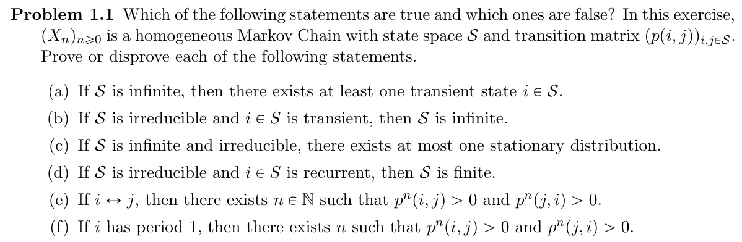









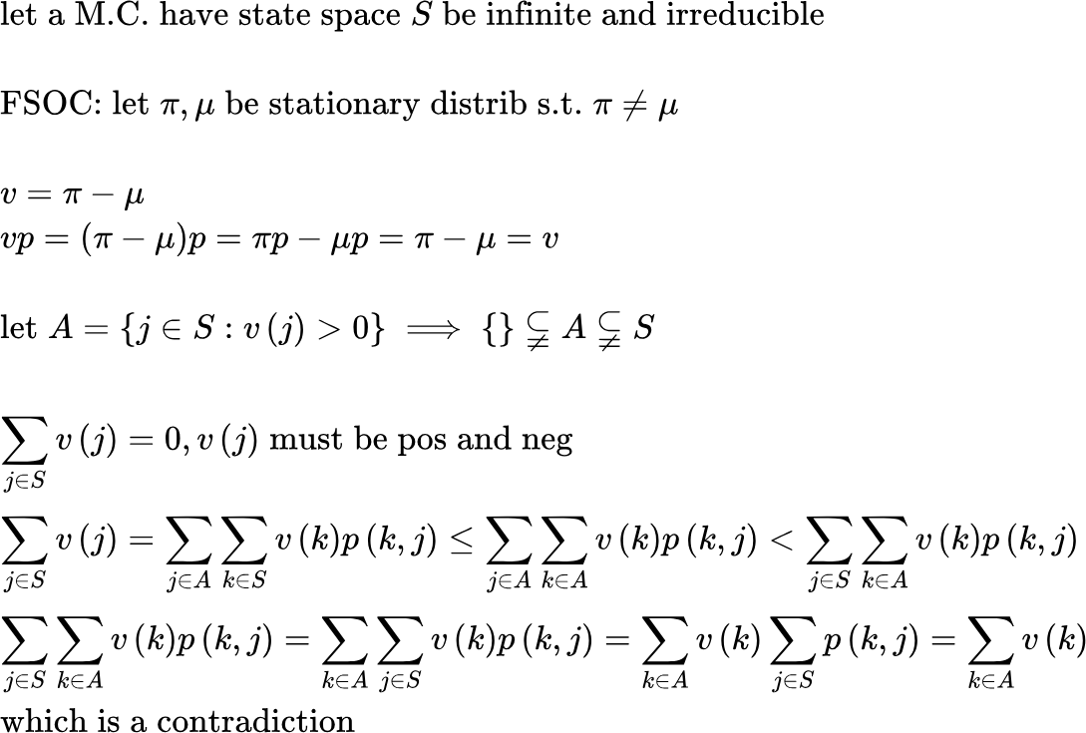







{"aid":null,"id":"29","type":"lalign*","font":{"size":11,"family":"Arial","color":"#000000"},"code":"\\begin{lalign*}\n&{\\text{false}\\;i\\leftrightarrow j\\implies \\exists a,b\\in\\mathbb{N}\\;\\text{s.t.}\\;p^{n_{1}}\\left(i,j\\right)>0\\;\\text{and}\\;p^{a}\\left(i,j\\right)>0,p^{b}\\left(j,i\\right)>0}\\\\\n&{}\\\\\n&{}\\\\\n&{}\t\n\\end{lalign*}","backgroundColor":"#ffffff","ts":1714947742260,"cs":"sN1bvBbCECY5wnki751+hg==","size":{"width":528,"height":20}}

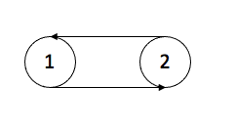

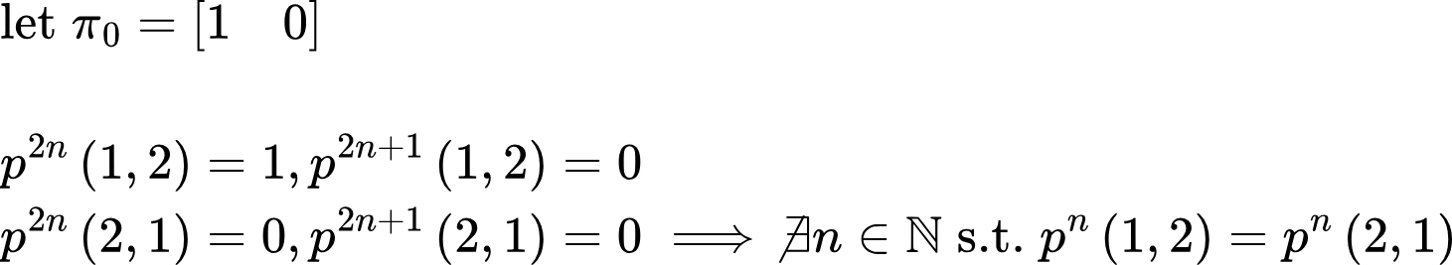



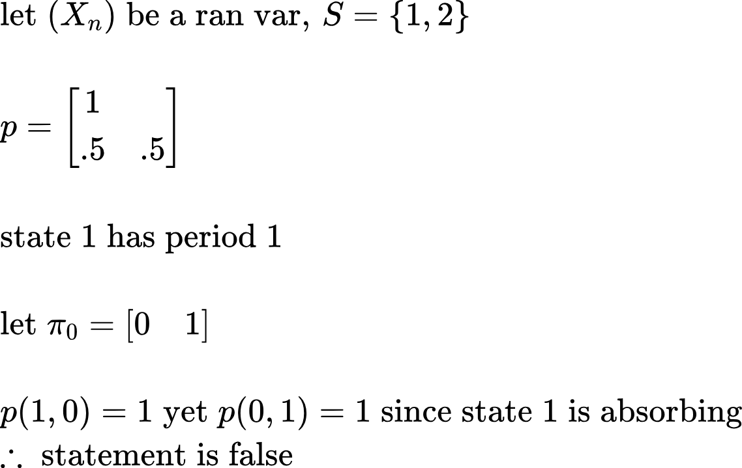

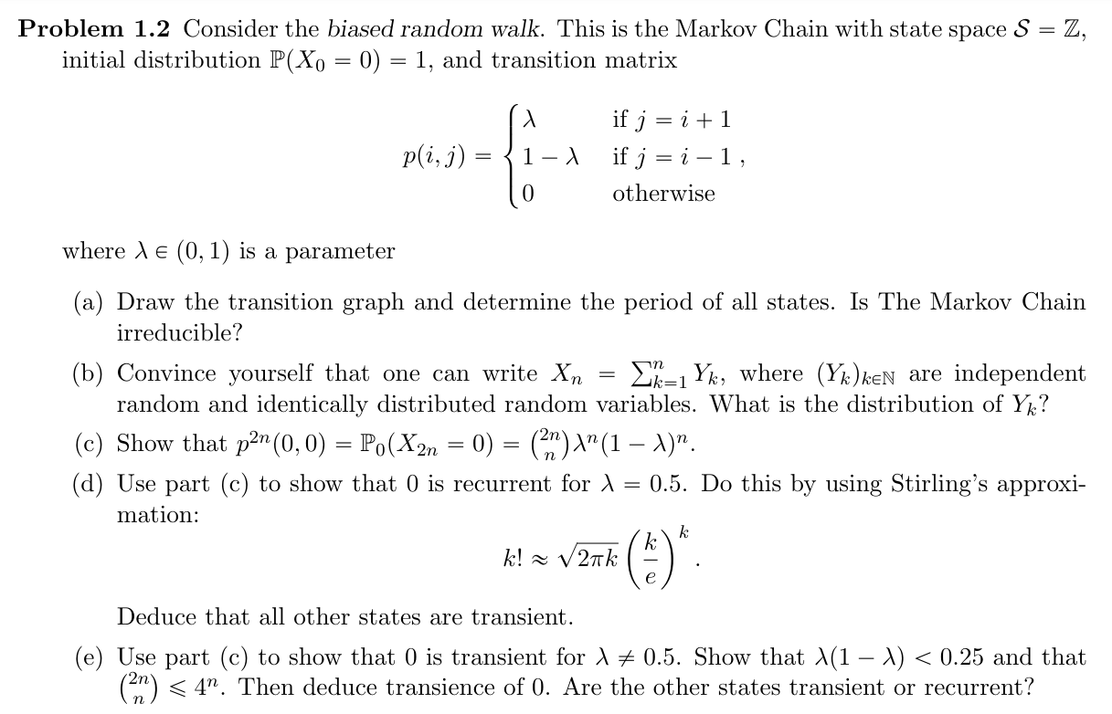  
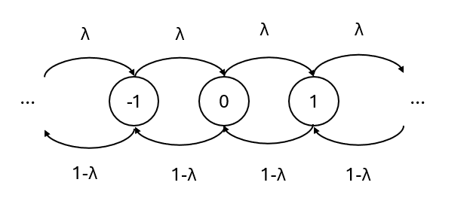

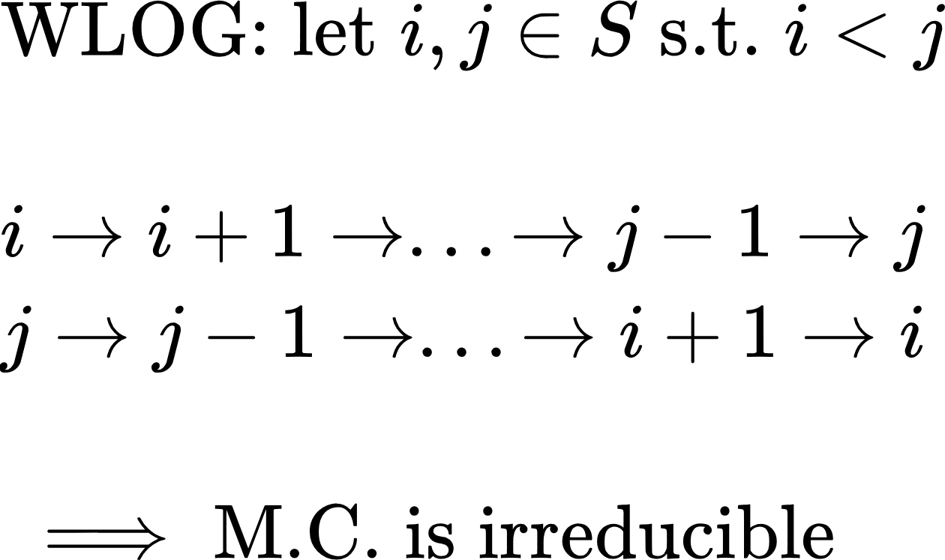



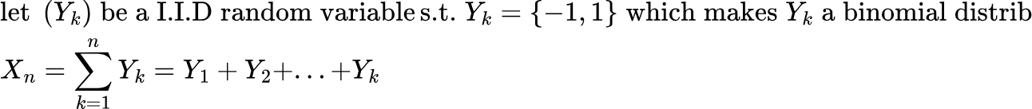



{"backgroundColor":"#ffffff","code":"\\begin{lalign*}\n&{p^{2}=\\begin{bmatrix}\n{}&{\\ddots}&{}&{}&{}\\\\\n{\\ddots}&{}&{\\lambda}&{}&{}\\\\\n{}&{1-\\lambda}&{}&{\\lambda}&{}\\\\\n{}&{}&{1-\\lambda}&{}&{\\ddots}\\\\\n{}&{}&{}&{\\ddots}&{}\\\\\n\\end{bmatrix}\\begin{bmatrix}\n{}&{\\ddots}&{}&{}&{}\\\\\n{\\ddots}&{}&{\\lambda}&{}&{}\\\\\n{}&{1-\\lambda}&{}&{\\lambda}&{}\\\\\n{}&{}&{1-\\lambda}&{}&{\\ddots}\\\\\n{}&{}&{}&{\\ddots}&{}\\\\\n\\end{bmatrix}}\\\\\n&{\\left(p^{2}\\right)^{n}=\\begin{bmatrix}\n{\\ddots}&{}&{\\ddots}&{}&{}&{}&{}\\\\\n{}&{2\\lambda\\left(1-\\lambda\\right)}&{}&{\\lambda^{2}}&{}&{}&{}\\\\\n{\\ddots}&{}&{2\\lambda\\left(1-\\lambda\\right)}&{}&{\\lambda^{2}}&{}&{}\\\\\n{}&{\\left(1-\\lambda\\right)^{2}}&{}&{2\\lambda\\left(1-\\lambda\\right)}&{}&{\\lambda^{2}}&{}\\\\\n{}&{}&{\\left(1-\\lambda\\right)^{2}}&{}&{2\\lambda\\left(1-\\lambda\\right)}&{}&{\\ddots}\\\\\n{}&{}&{}&{\\left(1-\\lambda\\right)^{2}}&{}&{2\\lambda\\left(1-\\lambda\\right)}&{}\\\\\n{}&{}&{}&{}&{\\ddots}&{}&{\\ddots}\\\\\n\\end{bmatrix}^{n}}\\\\\n&{}\\\\\n&{}\\\\\n&{\\left(p^{2}\\left(0,0\\right)\\right)^{2}=\\begin{bmatrix}\n{\\left(1-\\lambda\\right)^{2}}&{2\\lambda\\left(1-\\lambda\\right)}&{\\lambda^{2}}\\\\\n\\end{bmatrix}\\begin{bmatrix}\n{\\lambda^{2}}\\\\\n{2\\lambda\\left(1-\\lambda\\right)}\\\\\n{\\left(1-\\lambda\\right)^{2}}\\\\\n\\end{bmatrix}}\\\\\n&{\\left(p^{2}\\left(0,0\\right)\\right)^{2}=\\left(1-\\lambda\\right)^{2}\\lambda^{2}+\\left(2\\lambda\\left(1-\\lambda\\right)\\right)^{2}+\\lambda^{2}\\left(1-\\lambda\\right)^{2}=2\\lambda^{2}\\left(1-\\lambda\\right)^{2}+4\\lambda^{2}\\left(1-\\lambda\\right)^{2}=6\\lambda^{2}\\left(1-\\lambda\\right)^{2}}\\\\\n&{\\left(p^{2}\\left(0,0\\right)\\right)^{2}=\\binom{2\\cdot2}{2}\\lambda^{2}\\left(1-\\lambda\\right)^{2}}\\\\\n&{\\left(p^{2}\\left(0,0\\right)\\right)^{3}=\\begin{bmatrix}\n{\\left(1-\\lambda\\right)^{2}}&{2\\lambda\\left(1-\\lambda\\right)}&{\\lambda^{2}}\\\\\n\\end{bmatrix}\\begin{bmatrix}\n{2\\left(2\\lambda\\left(1-\\lambda\\right)\\left(1-\\lambda\\right)^{2}\\right)}\\\\\n{6\\lambda^{2}\\left(1-\\lambda\\right)^{2}}\\\\\n{2\\left(2\\lambda\\left(1-\\lambda\\right)\\left(\\lambda\\right)^{2}\\right)}\\\\\n\\end{bmatrix}}\\\\\n&{\\left(p^{2}\\left(0,0\\right)\\right)^{3}=\\begin{bmatrix}\n{\\left(1-\\lambda\\right)^{2}}&{2\\lambda\\left(1-\\lambda\\right)}&{\\lambda^{2}}\\\\\n\\end{bmatrix}\\begin{bmatrix}\n{4\\lambda\\left(1-\\lambda\\right)\\left(1-\\lambda\\right)^{2}}\\\\\n{6\\lambda^{2}\\left(1-\\lambda\\right)^{2}}\\\\\n{4\\lambda\\left(1-\\lambda\\right)\\left(\\lambda\\right)^{2}}\\\\\n\\end{bmatrix}}\\\\\n&{\\left(p^{2}\\left(0,0\\right)\\right)^{3}=4\\lambda\\left(1-\\lambda\\right)\\left(1-\\lambda\\right)^{2}\\left(1-\\lambda\\right)^{2}+2\\lambda\\left(1-\\lambda\\right)\\left(6\\lambda^{2}\\left(1-\\lambda\\right)^{2}\\right)+\\lambda^{2}4\\lambda\\left(1-\\lambda\\right)\\left(\\lambda\\right)^{2}}\\\\\n&{\\left(p^{2}\\left(0,0\\right)\\right)^{3}=4\\lambda\\left(1-\\lambda\\right)\\left(1-\\lambda\\right)^{4}+12\\lambda^{3}\\left(1-\\lambda\\right)^{3}+4\\lambda\\left(1-\\lambda\\right)\\left(\\lambda\\right)^{4}}\\\\\n&{\\left(p^{2}\\left(0,0\\right)\\right)^{3}=4\\left(1-\\lambda\\right)^{3}\\lambda\\left(\\lambda-1\\right)^{2}+12\\lambda^{3}\\left(1-\\lambda\\right)^{3}+4\\lambda^{3}\\left(1-\\lambda\\right)\\left(\\lambda\\right)^{2}=20\\lambda^{3}\\left(1-\\lambda\\right)^{3}=\\binom{2\\cdot3}{2}\\lambda^{3}\\left(1-\\lambda\\right)^{3}}\\\\\n&{\\vdots}\\\\\n&{\\left(p^{2}\\left(0,0\\right)\\right)^{n}=\\binom{2n}{n}\\lambda^{n}\\left(1-\\lambda\\right)^{n}}\\\\\n&{}\\\\\n&{}\\\\\n&{}\t\n\\end{lalign*}","aid":null,"id":"16","font":{"family":"Arial","size":9,"color":"#000000"},"type":"lalign*","ts":1714881098158,"cs":"gedXY10J5TVKnbL6UBYfHA==","size":{"width":617,"height":790}}



{"aid":null,"backgroundColor":"#ffffff","font":{"family":"Arial","size":9.5,"color":"#000000"},"code":"\\begin{lalign*}\n&{\\text{by}\\;\\text{part}\\;\\text{c:}}\\\\\n&{\\left(p^{2}\\left(0,0\\right)\\right)^{n}=\\binom{2n}{n}\\lambda^{n}\\left(1-\\lambda\\right)^{n}=\\frac{\\left(2n\\right)!}{\\left(2n-n\\right)!\\cdot n!}\\lambda^{n}\\left(1-\\lambda\\right)^{n}=\\frac{\\left(2n\\right)!}{n!\\cdot n!}\\lambda^{n}\\left(1-\\lambda\\right)^{n}=\\frac{\\left(2n\\right)!}{\\left(n!\\right)^{2}}\\left(\\frac{1}{4}\\right)^{n}}\\\\\n&{\\left(p^{2}\\left(0,0\\right)\\right)^{n}=\\frac{\\left(2n\\right)!}{\\left(n!\\right)^{2}}\\left(\\frac{1}{4}\\right)^{n}=\\frac{{\\sqrt[]{2\\pi \\cdot2n}}\\left(\\frac{2n}{e}\\right)^{2n}}{\\left({\\sqrt[]{2\\pi \\cdot n}}\\left(\\frac{n}{e}\\right)^{n}\\right)^{2}}\\left(\\frac{1}{4}\\right)^{n}=\\frac{2{\\sqrt[]{\\pi n}}\\left(\\frac{n}{e}\\right)^{2n}\\cdot4^{n}}{2\\pi n\\left(\\frac{n}{e}\\right)^{2n}}\\left(\\frac{1}{4}\\right)^{n}=\\frac{4^{n}}{{\\sqrt[]{\\pi n}}}\\left(\\frac{1}{4}\\right)^{n}=\\frac{1}{{\\sqrt[]{\\pi n}}}}\\\\\n&{\\text{WTS:}\\;P_{0}\\left(T_{0}<\\infty\\right)=1\\;\\text{or}\\;P_{0}\\left(T_{0}=\\infty\\right)=0}\\\\\n&{}\\\\\n&{P_{0}\\left(T_{0}<\\infty\\right)=1\\iff \\lim_{n\\to \\infty}\\left(p^{2}\\left(0,0\\right)^{n}\\right)>0}\\\\\n&{\\sum_{n=1}^{\\infty}\\left(p^{2}\\left(0,0\\right)\\right)^{n}=\\sum_{n=1}^{\\infty}\\frac{1}{{\\sqrt[]{\\pi n}}}=\\sum_{n=1}^{\\infty}\\frac{1}{{\\sqrt[]{\\pi}}}\\left(\\frac{1}{n}\\right)^{\\frac{1}{2}}=\\infty>0}\\\\\n&{\\implies\\text{state}\\;0\\;\\text{is}\\;\\text{recurrent}\\;\\implies P_{0}\\left(T_{0}<\\infty\\right)=1}\\\\\n&{}\\\\\n&{\\text{since}\\;\\text{state}\\;0\\;\\text{is}\\;\\text{the}\\;\\text{intial}\\;\\text{distrib}\\;\\text{this}\\;\\text{will}\\;\\text{created}\\;\\text{a}\\;\\text{gaussian}\\;\\text{distrib}\\;\\text{which}\\;\\text{will}\\;\\text{causes}}\\\\\n&{0\\;\\text{to}\\;\\text{recurrently}\\;\\text{be}\\;\\text{returned}\\;\\text{but}\\;\\text{other}\\;\\text{states}\\;\\text{is}\\;\\text{not}\\;\\text{gurannted}\\;\\text{thus}\\;\\text{all}\\;\\text{states}\\;\\text{that}\\;\\text{are}\\;\\text{not}\\;\\text{0}\\;\\text{are}\\;\\text{transient}\\;\\text{}}\\\\\n&{}\t\n\\end{lalign*}","type":"lalign*","id":"26","ts":1714970657071,"cs":"abc54+0nO43h8Yf3Gz1yGg==","size":{"width":674,"height":312}}



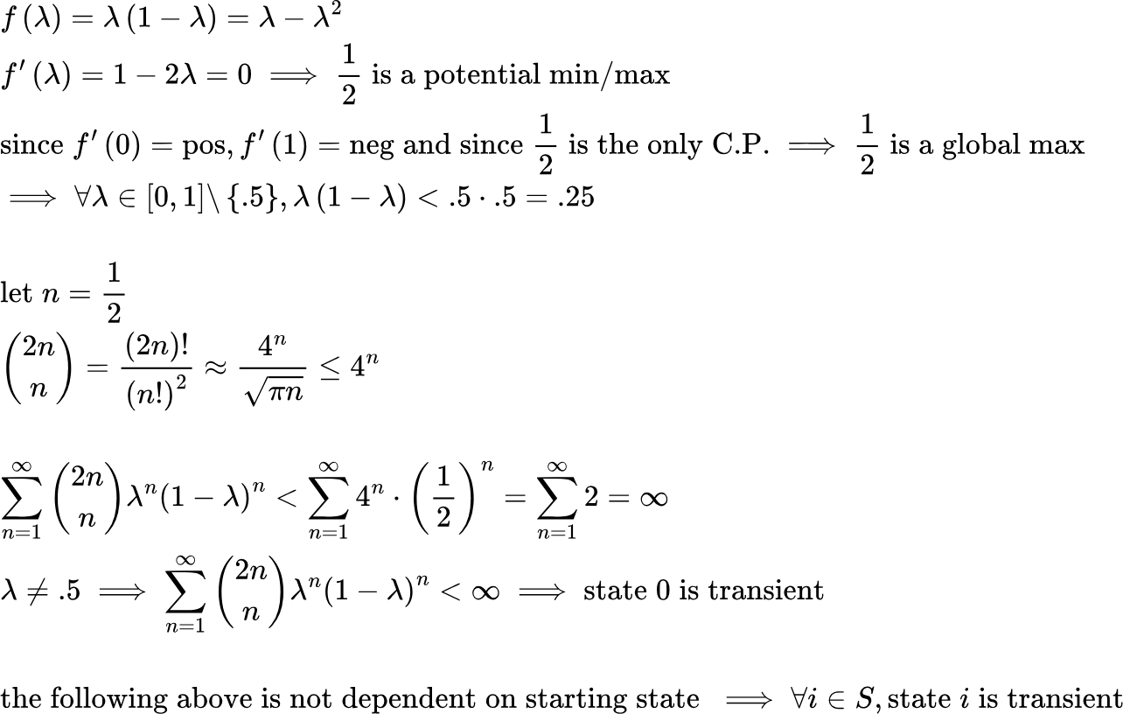

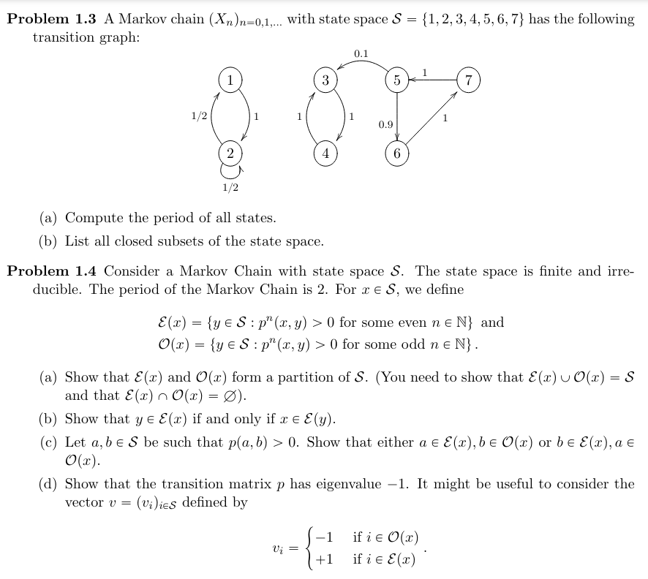

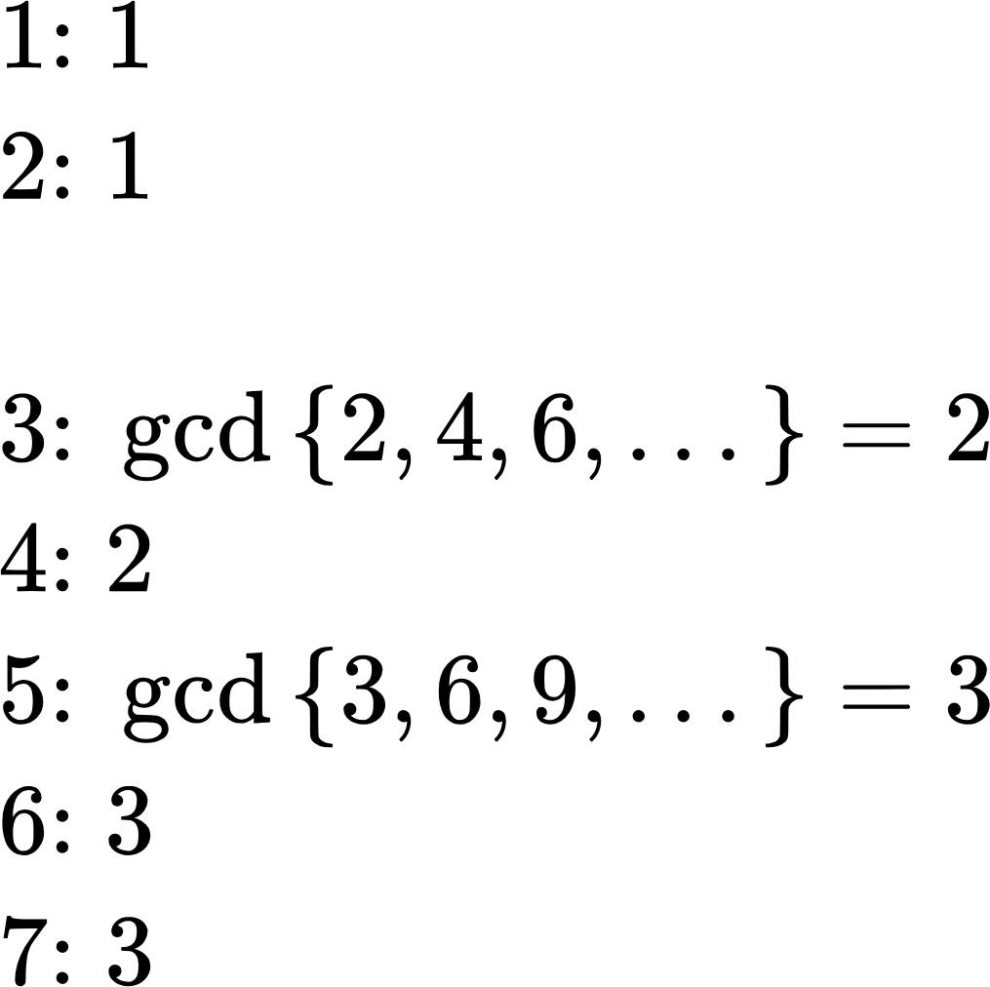



{"type":"$$","id":"3","font":{"size":11,"family":"Arial","color":"#000000"},"code":"$$\\left\\{\\right\\},\\left\\{1,2\\right\\},\\left\\{3,4\\right\\},\\left\\{1,2,3,4\\right\\},\\left\\{3,4,5,6,7\\right\\},\\left\\{1,2,3,4,5,6,7\\right\\}$$","aid":null,"backgroundColor":"#ffffff","ts":1718169544920,"cs":"zaSGMsITA8AyPzzIb6Cvbw==","size":{"width":425,"height":16}}



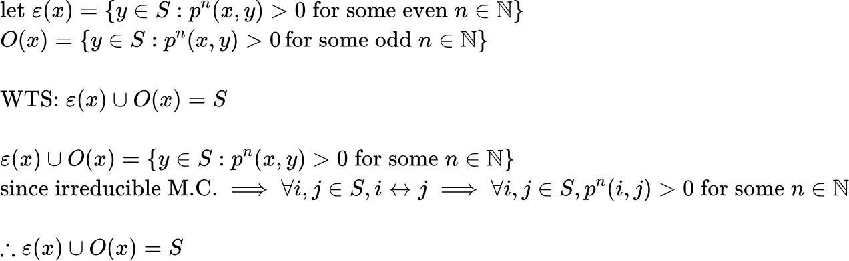

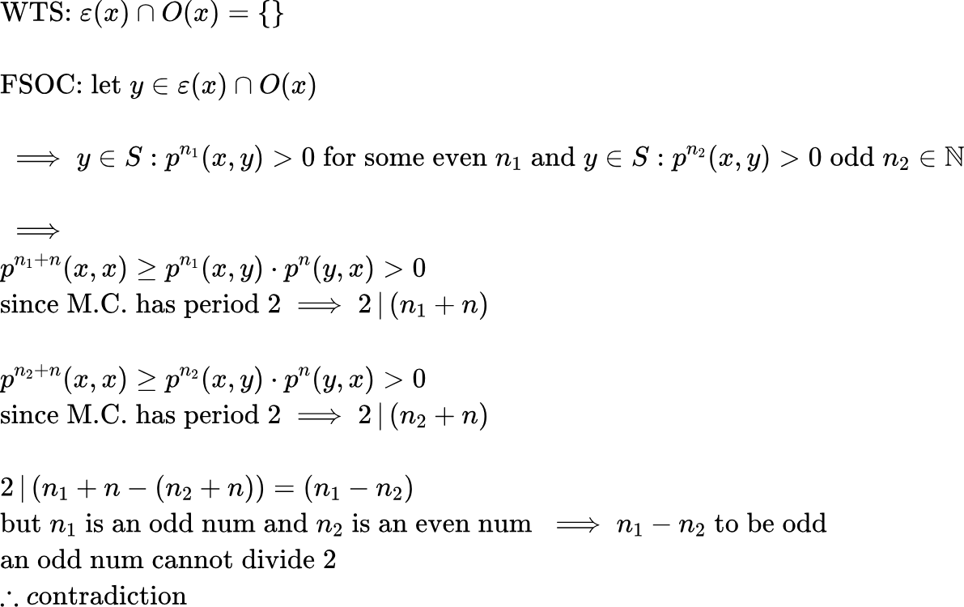



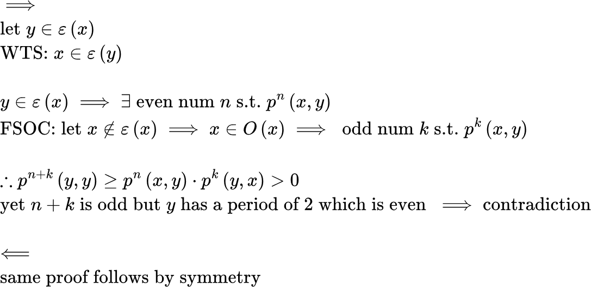



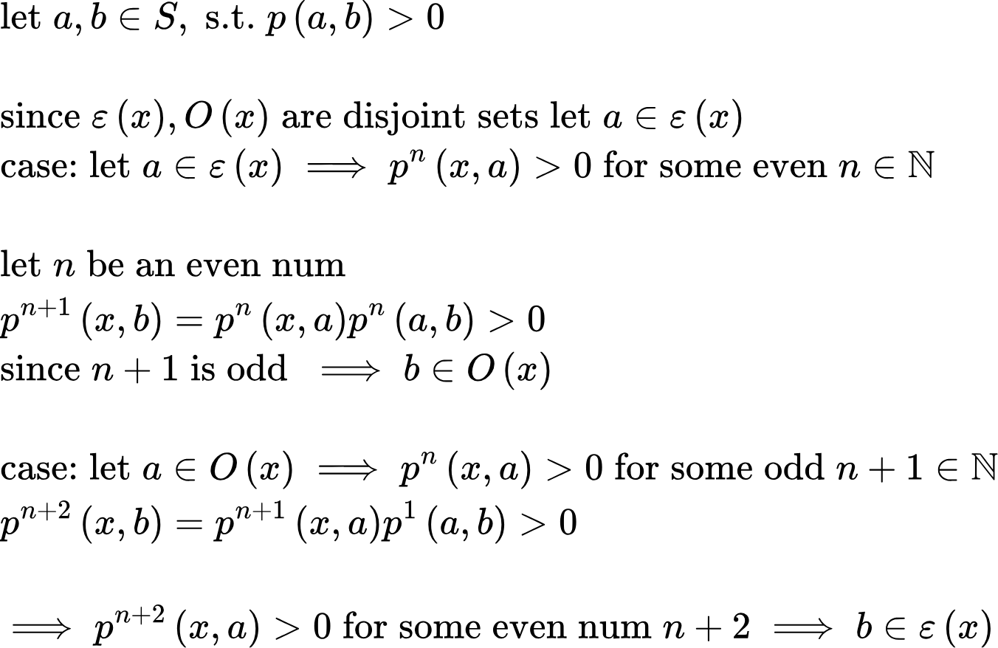



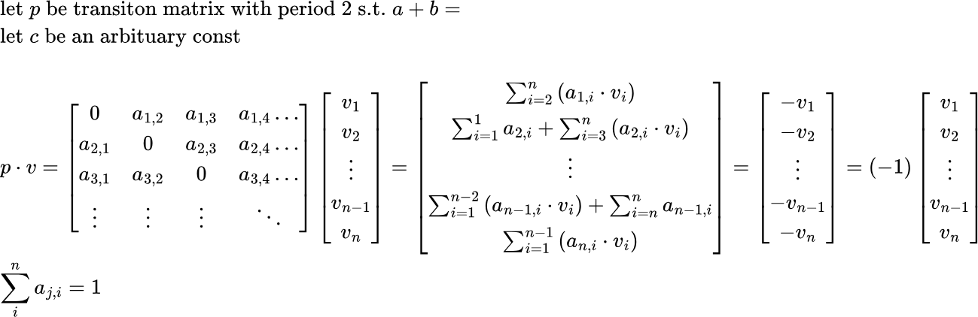

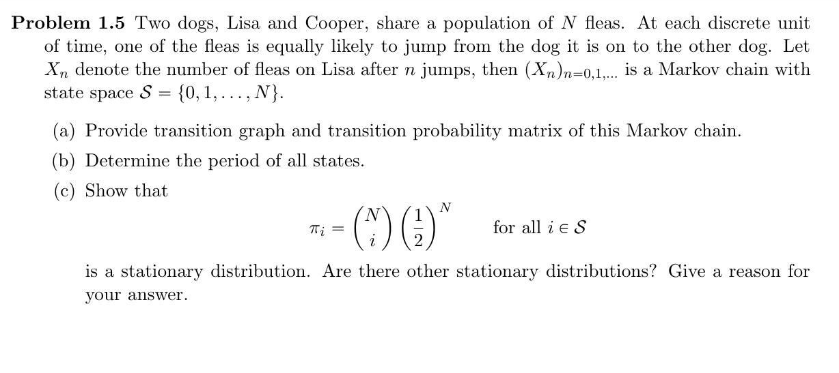

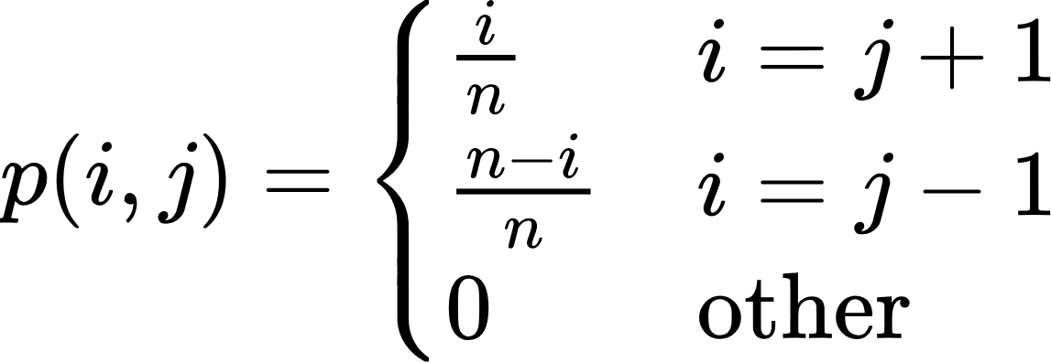

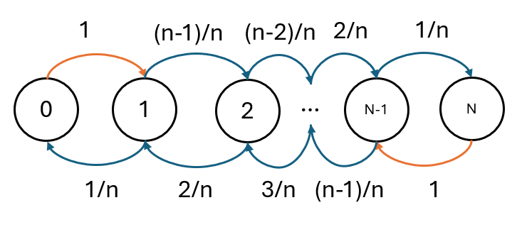



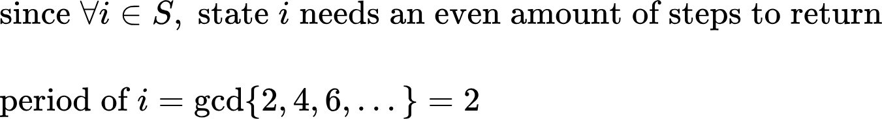



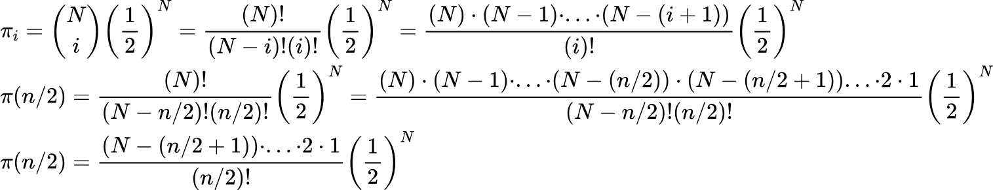

{"backgroundColor":"#ffffff","id":"14-0","aid":null,"type":"lalign*","font":{"size":8,"color":"#000000","family":"Arial"},"code":"\\begin{lalign*}\n&{p=\\begin{bmatrix}\n{0}&{1}&{0}&{0}&{\\dots}&{0}\\\\\n{\\frac{1}{n}}&{0}&{\\frac{n-1}{n}}&{0}&{\\dots}&{0}\\\\\n{0}&{\\frac{2}{n}}&{0}&{\\frac{n-2}{n}}&{\\dots}&{0}\\\\\n{\\vdots}&{\\ddots}&{\\ddots}&{\\ddots}&{\\ddots}&{\\vdots}\\\\\n{0}&{\\dots}&{0}&{\\frac{n-1}{n}}&{0}&{\\frac{1}{n}}\\\\\n{0}&{\\dots}&{0}&{0}&{1}&{0}\\\\\n\\end{bmatrix}}\\\\\n&{}\\\\\n&{\\begin{bmatrix}\n{\\pi\\left(0\\right)}&{\\pi\\left(1\\right)}&{\\dots}&{\\pi\\left(n/2\\right)}&{\\dots}&{\\pi\\left(n-1\\right)}&{\\pi\\left(n\\right)}\\\\\n\\end{bmatrix}=\\begin{bmatrix}\n{\\binom{n}{0}\\left(\\frac{1}{2}\\right)^{n}}&{\\binom{n}{1}\\left(\\frac{1}{2}\\right)^{n}}&{\\dots}&{\\binom{n}{n/2}\\left(\\frac{1}{2}\\right)^{n}}&{\\dots}&{\\binom{n}{n-1}\\left(\\frac{1}{2}\\right)^{n}}&{\\binom{n}{n}\\left(\\frac{1}{2}\\right)^{n}}\\\\\n\\end{bmatrix}}\\\\\n&{\\begin{bmatrix}\n{\\pi\\left(0\\right)}&{\\pi\\left(1\\right)}&{\\dots}&{\\pi\\left(n/2\\right)}&{\\dots}&{\\pi\\left(n-1\\right)}&{\\pi\\left(n\\right)}\\\\\n\\end{bmatrix}=\\begin{bmatrix}\n{\\left(\\frac{1}{2}\\right)^{n}}&{n\\left(\\frac{1}{2}\\right)^{n}}&{\\dots}&{\\frac{\\left(n\\right)\\left(n-1\\right)\\cdot\\dots\\,\\cdot \\left(n-\\left(n/2-1\\right)\\right)}{\\left(n/2\\right)!}\\left(\\frac{1}{2}\\right)^{n}}&{\\dots}&{n\\left(\\frac{1}{2}\\right)^{n}}&{\\left(\\frac{1}{2}\\right)^{n}}\\\\\n\\end{bmatrix}}\\\\\n&{}\\\\\n&{\\sum_{i=0}^{n}\\pi\\left(i\\right)=\\sum_{i=0}^{n}\\binom{n}{i}\\left(\\frac{1}{2}\\right)^{n}=2^{n}\\left(\\frac{1}{2}\\right)^{n}=1\\;\\;\\;\\left(\\text{series}\\;\\text{sum}\\;\\text{of}\\;\\text{combination}\\;\\text{can}\\;\\text{be}\\;\\text{proven}\\;\\text{with}\\;\\text{induction}\\right)}\\\\\n&{}\\\\\n&{\\begin{bmatrix}\n{\\left(\\frac{1}{2}\\right)^{n}}&{n\\left(\\frac{1}{2}\\right)^{n}}&{\\dots}&{\\frac{\\left(n\\right)\\left(n-1\\right)\\cdot\\dots\\,\\cdot \\left(n-\\left(n/2-1\\right)\\right)}{\\left(n/2\\right)!}\\left(\\frac{1}{2}\\right)^{n}}&{\\dots}&{n\\left(\\frac{1}{2}\\right)^{n}}&{\\left(\\frac{1}{2}\\right)^{n}}\\\\\n\\end{bmatrix}\\begin{bmatrix}\n{-1}&{1}&{0}&{0}&{\\dots}&{0}\\\\\n{\\frac{1}{n}}&{-1}&{\\frac{n-1}{n}}&{0}&{\\dots}&{0}\\\\\n{0}&{\\frac{2}{n}}&{-1}&{\\frac{n-2}{n}}&{\\dots}&{0}\\\\\n{\\vdots}&{\\ddots}&{\\ddots}&{\\ddots}&{\\ddots}&{\\vdots}\\\\\n{0}&{\\dots}&{0}&{\\frac{n-1}{n}}&{-1}&{\\frac{1}{n}}\\\\\n{0}&{\\dots}&{0}&{0}&{1}&{-1}\\\\\n\\end{bmatrix}=\\begin{bmatrix}\n{0}&{\\dots}&{0}\\\\\n\\end{bmatrix}}\\\\\n&{}\\\\\n&{-\\pi\\left(0\\right)+\\frac{1}{n}\\pi\\left(1\\right)=-\\left(\\frac{1}{2}\\right)^{n}+\\frac{1}{n}\\cdot n\\left(\\frac{1}{2}\\right)^{n}=0}\\\\\n&{\\pi\\left(0\\right)-\\pi\\left(1\\right)+\\frac{2}{n}\\pi\\left(2\\right)=-\\left(n+1\\right)\\left(\\frac{1}{2}\\right)^{n}+\\frac{2}{n}\\left(\\frac{n\\left(n+1\\right)}{2}\\right)\\left(\\frac{1}{2}\\right)^{n}=0}\\\\\n&{\\vdots}\\\\\n&{\\frac{1}{2}\\pi\\left(n/2\\right)=\\frac{1}{2}\\pi\\left(n/2\\right)}\\\\\n&{\\vdots}\\\\\n&{\\frac{1}{n}\\pi\\left(n-1\\right)-\\pi\\left(n\\right)=\\frac{1}{n}\\cdot n\\left(\\frac{1}{2}\\right)^{n}-\\left(\\frac{1}{2}\\right)^{n}=0}\\\\\n&{\\pi\\left(0\\right)-\\pi\\left(1\\right)+\\frac{2}{n}\\pi\\left(2\\right)=}\\\\\n&{\\frac{2}{n}\\pi\\left(n-2\\right)-\\pi\\left(n-1\\right)+\\pi\\left(n\\right)=\\frac{2}{n}\\left(\\frac{n\\left(n+1\\right)}{2}\\right)\\left(\\frac{1}{2}\\right)^{n}-\\left(n+1\\right)\\left(\\frac{1}{2}\\right)^{n}=0}\\\\\n&{}\\\\\n&{\\text{since}\\;\\text{finite}\\;\\text{closed}\\;\\text{and}\\;\\text{irreducible}\\;\\implies\\text{unique}\\;\\text{stationary}\\;\\text{distrib}}\\\\\n&{}\\\\\n&{}\\\\\n&{}\t\n\\end{lalign*}","ts":1714950810383,"cs":"Sv/so1hCDdcgqz6B6O4nPA==","size":{"width":668,"height":669}}

